“ When we found out we were pregnant with our third baby my husband and I were excited but also a little apprehensive. While this wasn’t our first rodeo with parenthood, it was our first-time navigating pregnancy outside of active duty military and the choices we had seemed endless.

After two inductions that resulted in long labors and epidurals, I decided I wanted to try to have this baby as natural as possible but had no clue how to prepare my body, mind, and husband for that process. Stumbling across Kim as a doula was the best thing that could’ve happened for me this pregnancy.

Through anxiety and emotional roller coasters as well as physical aches and pains, she was always there (whether it be a in person visit, phone call, or email). During our visits she always took time to show my husband specific techniques and strategies to alleviate my pains as well as stress relief using holistic techniques, essential oils, massage, stretching, and breathing. When I found out I would be induced with this baby, though I was discouraged, Kim continued to remind me that I could still finish this process naturally without pain medication. She remained by my side the entire 18-hour labor and delivery, providing natural pain relief and affirmations. She also empowered my husband to actively participate throughout the labor and delivery, which was an amazing experience. I am proud to say I successfully brought my son earthbound as naturally as I possibly could, despite the induction, thanks to Kim and all the strategies and techniques I learned through working with her. ”
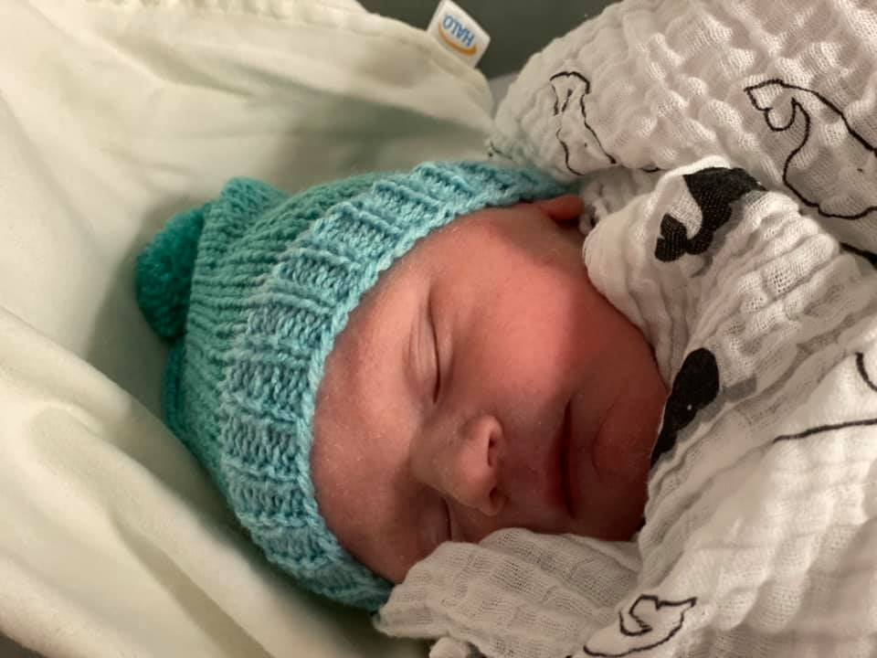
Love always!

Hayley

